EXPT NO: 6 | IMPLEMENTATION OF LONG SHORT-TERM MEMORY (LSTM) FOR SENTIMENT ANALYSIS
DATE:

PRE-LAB QUESTIONS (PROVIDE BRIEF ANSWERS TO THE FOLLOWING QUESTIONS)

1. Explain the working of Long Short-Term Memory (LSTM) networks in processing sequential data.

LSTM is a type of Recurrent Neural Network (RNN) designed to process sequential data and learn long-term dependencies. It processes data step by step while maintaining information in its memory cells. Gates control the information to remember, update, or forget. This helps LSTM learn patterns in sequences such as text, speech, and time-series data.

2. Discuss why is LSTM considered suitable for sentiment analysis of textual data?

LSTM is suitable for sentiment analysis because it can understand the context and sequence of words in a sentence. It captures long-term dependencies and relationships between words. This helps identify positive, negative, or neutral emotions in text. It can also understand how word order affects the overall sentiment.

3. Explain the role of memory cells and gates in an LSTM network.

Memory cells store important information from previous steps in a sequence. LSTM uses three main gates: the forget gate, input gate, and output gate. The forget gate removes unnecessary information, while the input gate adds new information. The output gate determines which information is passed to the next step.

4. Explain the importance of tokenization during text preprocessing for sentiment analysis.

Tokenization is the process of splitting text into smaller units, such as words or subwords. It helps organize textual data into manageable units for further processing. Each token can be assigned a numerical index for model training. Proper tokenization improves the model's ability to learn patterns and understand sentiment.

5. Why should textual data be converted into numerical representations before training an LSTM model?

LSTM models cannot directly process raw text because they require numerical inputs. Text is converted into numerical representations using methods such as token indexing, word embeddings, or vectorization. These representations allow the model to learn relationships and patterns between words. This helps the LSTM perform sentiment classification effectively.

AIM
To implement a Long Short-Term Memory (LSTM) neural network for sentiment analysis and classify textual data into appropriate sentiment categories based on the learned linguistic patterns.

SOFTWARE REQUIREMENTS
- Python
- TensorFlow / Keras / PyTorch
- Google Colab
- GitHub
- NumPy
- Matplotlib
- Pandas

OBJECTIVES
Students will be able to:
- Understand the architecture and working of Long Short-Term Memory (LSTM) networks.
- Understand the role of LSTM in processing sequential textual data.
- Perform text preprocessing techniques for sentiment classification.
- Convert textual data into numerical sequences suitable for LSTM models.
- Build and train an LSTM-based sentiment classification model.
- Evaluate the performance of the trained LSTM using appropriate classification metrics.
- Analyze the effectiveness of LSTM in learning contextual and sequential patterns from textual data.

PROCEDURE
PART A: DATASET PREPARATION
Perform the following tasks:
- Load a suitable sentiment analysis dataset such as the IMDB Movie Reviews dataset.
- Explore the dataset and examine sample reviews and their corresponding sentiment labels.
- Identify the positive and negative sentiment classes.
- Perform basic text preprocessing such as converting text to lowercase, if required.
- Remove unnecessary characters or symbols, if required.
- Tokenize the reviews into words.
- Build a vocabulary and assign unique integer indices to words.
- Convert the text reviews into numerical sequences.
- Apply sequence padding to obtain inputs of equal length.
- Split the prepared dataset into training and validation/testing datasets.

Code:
# Name: Mithunjai. E
# Roll No: 24BAD071
# Experiment: LSTM-Based Sentiment Analysis
# PART A: DATASET PREPARATION

# 1. Import required libraries
import numpy as np
import pandas as pd
import matplotlib.pyplot as plt
import re
import tensorflow as tf

from tensorflow.keras.datasets import imdb
from tensorflow.keras.preprocessing.sequence import pad_sequences
from sklearn.model_selection import train_test_split

print("Name: Mithunjai. E")
print("Roll Number: 24BAD071")
print("Experiment: LSTM-Based Sentiment Analysis")
print("TensorFlow Version:", tf.__version__)

# 2. Set dataset parameters
MAX_FEATURES = 10000
MAX_LEN = 200

# 3. Load the IMDB dataset
(x_train_raw, y_train), (x_test_raw, y_test) = imdb.load_data(
num_words=MAX_FEATURES
)

print("\nDATASET INFORMATION")
print("Training reviews:", len(x_train_raw))
print("Testing reviews:", len(x_test_raw))
print("First five labels:", y_train[:5])

# 4. Create a reverse word index to decode reviews
word_index = imdb.get_word_index()

reverse_word_index = {
index + 3: word for word, index in word_index.items()
}

reverse_word_index[0] = "<PAD>"
reverse_word_index[1] = "<START>"
reverse_word_index[2] = "<UNK>"
reverse_word_index[3] = "<UNUSED>"

# Function to convert integer sequences into readable text
def decode_review(sequence):
return " ".join(
reverse_word_index.get(token, "<UNK>")
for token in sequence
)

# 5. Display sample reviews and sentiment labels
print("\nSAMPLE REVIEWS")

for i in range(3):
print(f"\nReview {i + 1}")
print("Sentiment:",
"Positive" if y_train[i] == 1 else "Negative")
print("Review Text:")
print(decode_review(x_train_raw[i])[:500])

# 6. Display sentiment class distribution
class_counts = pd.Series(y_train).value_counts().sort_index()

print("\nSENTIMENT CLASS DISTRIBUTION")
print("Negative reviews:", class_counts.loc[0])
print("Positive reviews:", class_counts.loc[1])

# 7. Plot the sentiment distribution
plt.figure(figsize=(7, 5))

plt.bar(
["Negative", "Positive"],
[class_counts.loc[0], class_counts.loc[1]],
color=["tomato", "seagreen"]
)

plt.title("IMDB Movie Review Sentiment Distribution")
plt.xlabel("Sentiment Category")
plt.ylabel("Number of Reviews")
plt.grid(axis="y", alpha=0.3)
plt.tight_layout()
plt.show()

# 8. Convert reviews into equal-length padded sequences
x_train_padded = pad_sequences(
x_train_raw,
maxlen=MAX_LEN,
padding="post",
truncating="post"
)

x_test_padded = pad_sequences(
x_test_raw,
maxlen=MAX_LEN,
padding="post",
truncating="post"
)

# 9. Split training data into training and validation sets
x_train, x_val, y_train_final, y_val = train_test_split(
x_train_padded,
y_train,
test_size=0.20,
random_state=42,
stratify=y_train
)

# 10. Display final dataset shapes
print("\nFINAL DATASET SHAPES")
print("Training data:", x_train.shape)
print("Training labels:", y_train_final.shape)
print("Validation data:", x_val.shape)
print("Validation labels:", y_val.shape)
print("Testing data:", x_test_padded.shape)
print("Testing labels:", y_test.shape)

print("\nPART A COMPLETED SUCCESSFULLY!")
Output:
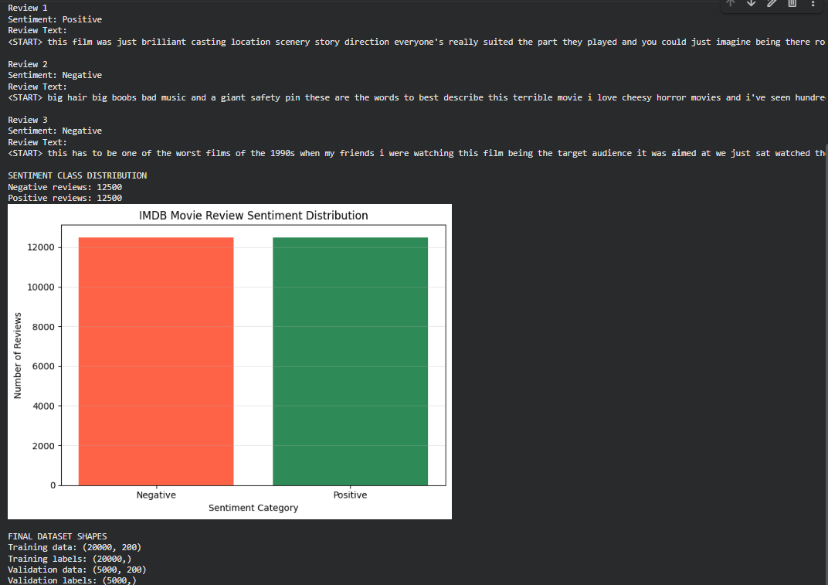
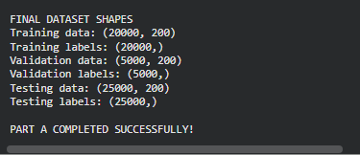
PART B: IMPLEMENTING THE LSTM MODEL
Perform the following tasks:
- Create an Embedding layer to convert words into dense vector representations.
- Add an LSTM layer to learn long-term sequential dependencies in the reviews.
- Add a Dense output layer for sentiment classification.
- Use an appropriate activation function such as Sigmoid for binary sentiment classification.
- Compile the model using an appropriate optimizer and loss function.
- Display the model architecture and model summary.

Code:
# Name: Mithunjai. E
# Roll No: 24BAD071
# Experiment: LSTM-Based Sentiment Analysis
# PART B: IMPLEMENTING THE LSTM MODEL

import tensorflow as tf
from tensorflow.keras.models import Sequential
from tensorflow.keras.layers import Embedding, LSTM, Dense, Dropout

# 1. Define model parameters
EMBEDDING_DIM = 128
LSTM_UNITS = 64

# 2. Create the LSTM model
model = Sequential([
Embedding(
input_dim=MAX_FEATURES,
output_dim=EMBEDDING_DIM,
mask_zero=True
),
LSTM(LSTM_UNITS),
Dropout(0.5),
Dense(1, activation="sigmoid")
])

# 3. Compile the model
model.compile(
optimizer="adam",
loss="binary_crossentropy",
metrics=["accuracy"]
)

# 4. Display the model architecture
model.build(input_shape=(None, MAX_LEN))

print("Name: Mithunjai. E")
print("Roll Number: 24BAD071")
print("\nLSTM MODEL SUMMARY")

model.summary()

# 5. Display model information
print("\nMODEL INFORMATION")
print("Input Shape:", model.input_shape)
print("Output Shape:", model.output_shape)
print("Total Parameters:", model.count_params())

# 6. Display individual layers
print("\nMODEL LAYERS")

for layer in model.layers:
print(layer.name, "-", layer.__class__.__name__)

# 7. Verify the model with sample training data
sample_input = x_train[:3]

sample_output = model.predict(sample_input, verbose=0)

print("\nMODEL VERIFICATION")
print("Input Shape:", sample_input.shape)
print("Output Shape:", sample_output.shape)
print("Initial Predicted Probabilities:")
print(sample_output.flatten())

print("\nPART B COMPLETED SUCCESSFULLY!")

Output:
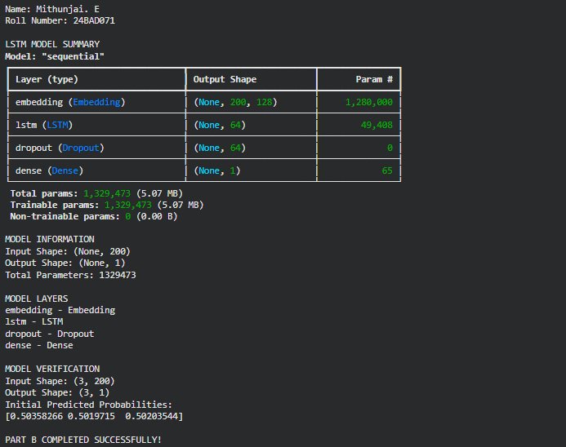

PART C: MODEL TRAINING AND PERFORMANCE EVALUATION
Perform the following tasks:
- Train the LSTM model using the prepared training dataset.
- Validate the model using the validation dataset.
- Record:
  - Training accuracy
  - Validation accuracy
  - Training loss
  - Validation loss
- Evaluate the trained model on the test dataset.
- Calculate suitable evaluation metrics such as:
  - Accuracy
  - Precision
  - Recall
  - F1-score
- Generate a confusion matrix to analyze the classification performance.
- Visualize:
  - Accuracy vs. Epoch
  - Loss vs. Epoch

Code:
# Name: Mithunjai. E
# Roll No: 24BAD071
# Experiment: LSTM-Based Sentiment Analysis
# PART C: MODEL TRAINING AND PERFORMANCE EVALUATION

import numpy as np
import pandas as pd
import matplotlib.pyplot as plt

from sklearn.metrics import (
accuracy_score,
precision_score,
recall_score,
f1_score,
confusion_matrix,
ConfusionMatrixDisplay,
classification_report
)

# 1. Define training parameters
EPOCHS = 5
BATCH_SIZE = 64

print("Name: Mithunjai. E")
print("Roll Number: 24BAD071")
print("\nSTARTING LSTM MODEL TRAINING")

# 2. Train the model and validate after each epoch
history = model.fit(
x_train,
y_train_final,
epochs=EPOCHS,
batch_size=BATCH_SIZE,
validation_data=(x_val, y_val),
verbose=1
)

print("\nMODEL TRAINING COMPLETED")

# 3. Record training and validation metrics
history_df = pd.DataFrame(history.history)
history_df.index = range(1, len(history_df) + 1)
history_df.index.name = "Epoch"

print("\nTRAINING AND VALIDATION HISTORY")
print(history_df.round(4).to_string())

print("\nFINAL EPOCH RESULTS")
print(f"Training Accuracy: {history.history['accuracy'][-1]:.4f}")
print(f"Validation Accuracy: {history.history['val_accuracy'][-1]:.4f}")
print(f"Training Loss: {history.history['loss'][-1]:.4f}")
print(f"Validation Loss: {history.history['val_loss'][-1]:.4f}")

# 4. Plot training and validation accuracy
epochs_range = range(1, len(history.history["accuracy"]) + 1)

plt.figure(figsize=(8, 5))
plt.plot(
epochs_range,
history.history["accuracy"],
marker="o",
label="Training Accuracy"
)
plt.plot(
epochs_range,
history.history["val_accuracy"],
marker="o",
label="Validation Accuracy"
)
plt.title("Training and Validation Accuracy vs Epoch")
plt.xlabel("Epoch")
plt.ylabel("Accuracy")
plt.xticks(list(epochs_range))
plt.legend()
plt.grid(True, alpha=0.3)
plt.tight_layout()
plt.show()

# 5. Plot training and validation loss
plt.figure(figsize=(8, 5))
plt.plot(
epochs_range,
history.history["loss"],
marker="o",
label="Training Loss"
)
plt.plot(
epochs_range,
history.history["val_loss"],
marker="o",
label="Validation Loss"
)
plt.title("Training and Validation Loss vs Epoch")
plt.xlabel("Epoch")
plt.ylabel("Binary Cross-Entropy Loss")
plt.xticks(list(epochs_range))
plt.legend()
plt.grid(True, alpha=0.3)
plt.tight_layout()
plt.show()

# 6. Evaluate the model on the test dataset
print("\nTEST DATASET EVALUATION")

test_loss, test_accuracy = model.evaluate(
x_test_padded,
y_test,
batch_size=256,
verbose=1
)

print(f"Test Loss: {test_loss:.4f}")
print(f"Test Accuracy: {test_accuracy:.4f}")
print(f"Test Accuracy (%): {test_accuracy * 100:.2f}%")

# 7. Predict test dataset sentiments
y_prob = model.predict(
x_test_padded,
batch_size=256,
verbose=1
).ravel()

y_pred = (y_prob >= 0.5).astype(int)

# 8. Calculate classification metrics
accuracy = accuracy_score(y_test, y_pred)
precision = precision_score(y_test, y_pred, zero_division=0)
recall = recall_score(y_test, y_pred, zero_division=0)
f1 = f1_score(y_test, y_pred, zero_division=0)

print("\nCLASSIFICATION METRICS")
print(f"Accuracy: {accuracy:.4f}")
print(f"Precision: {precision:.4f}")
print(f"Recall: {recall:.4f}")
print(f"F1-score: {f1:.4f}")

print("\nDETAILED CLASSIFICATION REPORT")
print(classification_report(
y_test,
y_pred,
labels=[0, 1],
target_names=["Negative", "Positive"],
digits=4,
zero_division=0
))

# 9. Generate the confusion matrix
cm = confusion_matrix(y_test, y_pred, labels=[0, 1])

print("\nCONFUSION MATRIX")
print(cm)

tn, fp, fn, tp = cm.ravel()

print("True Negatives:", tn)
print("False Positives:", fp)
print("False Negatives:", fn)
print("True Positives:", tp)

# 10. Visualize the confusion matrix
cm_display = ConfusionMatrixDisplay(
confusion_matrix=cm,
display_labels=["Negative", "Positive"]
)

cm_display.plot(cmap="Blues", values_format="d")
plt.title("LSTM Sentiment Analysis - Confusion Matrix")
plt.tight_layout()
plt.show()

print("\nPART C COMPLETED SUCCESSFULLY!")
Output:
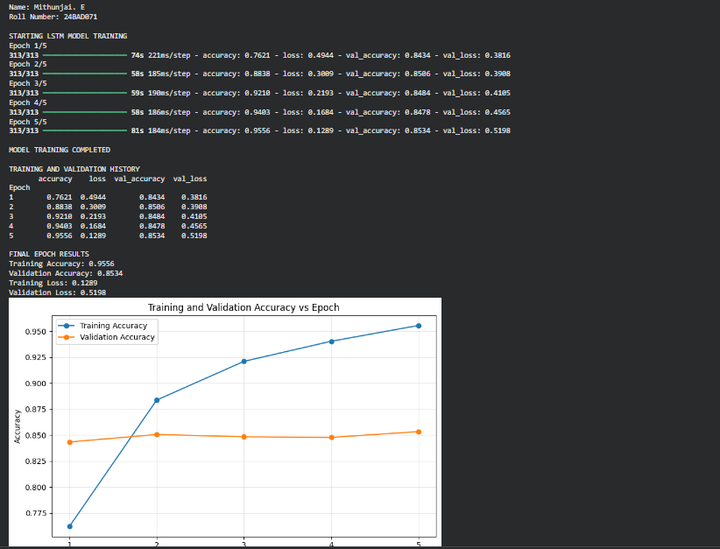

PART D: SENTIMENT PREDICTION AND DEEP LEARNING EXPERIMENT MANAGEMENT

Perform the following tasks:
- Provide new movie-review sentences as input to the trained LSTM model.
- Preprocess and tokenize the input text using the same vocabulary used during training.
- Apply sequence padding to the input text.
- Predict the sentiment using the trained LSTM model.
- Classify the input as Positive or Negative based on the predicted probability.
- Provide multiple review samples with different sentiments.
- Compare the predicted sentiment with the actual/expected sentiment.
- Analyze the coherence and correctness of the model predictions.
- Document the observations and upload the notebook to GitHub.

Code:
# Name: Mithunjai. E
# Roll No: 24BAD071
# Experiment: LSTM-Based Sentiment Analysis
# PART D: SENTIMENT PREDICTION AND EXPERIMENT MANAGEMENT

import re
import json
import pandas as pd
from tensorflow.keras.preprocessing.sequence import pad_sequences

print("Name: Mithunjai. E")
print("Roll Number: 24BAD071")

# 1. Preprocess new review text
def preprocess_new_review(text):
# Convert text to lowercase and extract words
words = re.findall(r"[a-zA-Z]+", text.lower())

# Add the IMDB start token
sequence = [1]

# Convert words to the original IMDB vocabulary indices
for word in words:
original_index = word_index.get(word)

if original_index is None:
token = 2
else:
token = original_index + 3

if token >= MAX_FEATURES:
token = 2

sequence.append(token)

# Pad the sequence to the required length
padded_sequence = pad_sequences(
[sequence],
maxlen=MAX_LEN,
padding="post",
truncating="post"
)

return padded_sequence

# 2. Predict sentiment using the trained model
def predict_sentiment(text):
processed_review = preprocess_new_review(text)

probability = float(
model.predict(processed_review, verbose=0)[0][0]
)

sentiment = "Positive" if probability >= 0.5 else "Negative"

return sentiment, probability

# 3. Predict a single new review
sample_review = (
"The movie was fantastic and the acting was brilliant."
)

sentiment, probability = predict_sentiment(sample_review)

print("\nSINGLE REVIEW PREDICTION")
print("Review:", sample_review)
print("Predicted Sentiment:", sentiment)
print(f"Positive Probability: {probability:.4f}")

# 4. Test multiple reviews with different sentiments
reviews = [
{
"Review": "This movie was fantastic, entertaining and beautifully acted.",
"Expected": "Positive"
},
{
"Review": "The film was boring, poorly written and a waste of time.",
"Expected": "Negative"
},
{
"Review": "I loved the story and the performances were excellent.",
"Expected": "Positive"
},
{
"Review": "The plot was confusing and the acting was terrible.",
"Expected": "Negative"
},
{
"Review": "The movie was not bad and had some enjoyable moments.",
"Expected": "Positive"
},
{
"Review": "The visuals were good, but the story was disappointing.",
"Expected": "Negative"
}
]

# 5. Compare expected and predicted sentiments
prediction_results = []

for item in reviews:
predicted, probability = predict_sentiment(item["Review"])

prediction_results.append({
"Review": item["Review"],
"Expected Sentiment": item["Expected"],
"Predicted Sentiment": predicted,
"Positive Probability": round(probability, 4),
"Correct": predicted == item["Expected"]
})

results_df = pd.DataFrame(prediction_results)

print("\nMULTIPLE REVIEW PREDICTIONS")
print(results_df.to_string(index=False))

# 6. Calculate agreement with expected labels
correct_count = int(results_df["Correct"].sum())
total_count = len(results_df)

print("\nPREDICTION SUMMARY")
print(f"Correct Predictions: {correct_count}/{total_count}")
print(
"Agreement with Expected Labels:",
f"{correct_count / total_count * 100:.2f}%"
)

# 7. Analyze incorrect predictions
print("\nINCORRECT PREDICTIONS")

incorrect_results = results_df[
results_df["Correct"] == False
]

if incorrect_results.empty:
print("All predictions match the expected labels.")
else:
for _, row in incorrect_results.iterrows():
print("\nReview:", row["Review"])
print("Expected:", row["Expected Sentiment"])
print("Predicted:", row["Predicted Sentiment"])
print("Positive Probability:", row["Positive Probability"])

# 8. Save the trained model
model.save("lstm_sentiment_model.keras")

# 9. Save prediction results
results_df.to_csv(
"sentiment_prediction_results.csv",
index=False
)

# 10. Save training history
history_df.to_csv("training_history.csv")

# 11. Save experiment configuration and metrics
experiment_info = {
"student_name": "Mithunjai. E",
"roll_number": "24BAD071",
"experiment": "LSTM-Based Sentiment Analysis",
"dataset": "IMDB Movie Reviews",
"vocabulary_size": MAX_FEATURES,
"sequence_length": MAX_LEN,
"embedding_dimension": EMBEDDING_DIM,
"lstm_units": LSTM_UNITS,
"epochs": EPOCHS,
"batch_size": BATCH_SIZE,
"test_accuracy": float(test_accuracy),
"test_loss": float(test_loss),
"precision": float(precision),
"recall": float(recall),
"f1_score": float(f1)
}

with open("experiment_results.json", "w") as file:
json.dump(experiment_info, file, indent=4)

print("\nSAVED EXPERIMENT FILES")
print("1. lstm_sentiment_model.keras")
print("2. sentiment_prediction_results.csv")
print("3. training_history.csv")
print("4. experiment_results.json")

print("\nPART D COMPLETED SUCCESSFULLY!")

Output:
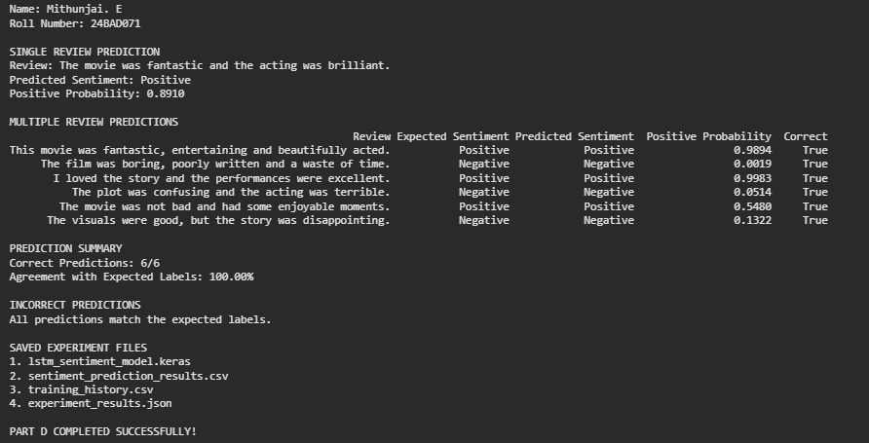

POST-LAB QUESTIONS (PROVIDE BRIEF ANSWERS TO THE FOLLOWING QUESTIONS)

- Explain how the cell state helps an LSTM retain information over long sequences.

The cell state acts as a memory unit that carries important information across long sequences. It allows the LSTM to preserve relevant information and reduce the vanishing gradient problem. This helps the model understand the context of movie reviews.

- Describe the functions of the input gate, forget gate, and output gate in an LSTM.

The input gate controls what new information is stored in the cell state. The forget gate decides which existing information should be removed or retained. The output gate determines which information from the cell state is used to produce the hidden state.

3. Discuss the effect of insufficient training epochs on the performance of an LSTM sentiment classification model.

Insufficient training epochs may prevent the LSTM from learning important linguistic patterns from the dataset. This can lead to underfitting and low training and validation accuracy. Increasing the epochs appropriately can improve performance, provided overfitting is monitored.

- Explain one advantage of LSTM over a Simple RNN for sentiment analysis.

LSTM can learn long-term dependencies in text more effectively than a Simple RNN. Its memory cell and gates help reduce the vanishing gradient problem. Therefore, it can better understand context across long movie reviews.

- Discuss how sequence length can affect the accuracy and computational requirements of an LSTM-based sentiment analysis model.

Longer sequences preserve more textual context, which may improve sentiment classification accuracy. However, they require more computation, memory, and training time. Shorter sequences train faster but may lose important information if reviews are truncated excessively.

ASSESSMENT
Description | Max Marks | Marks Awarded
Pre Lab Exercise | 5
In Lab Exercise | 10
Post Lab Exercise | 5
Viva | 10
Total | 30
Faculty Signature

